# **AWS Lambda — Launch EC2 Instances**

There are a variety of situations where having a microservice available that can manage (Create, start, stop or terminate) EC2 instances at will can be handy. In this article, we are going to see how we can use an AWS Lambda to do such a thing on demand without using any extra servers or instances at all.

we will write a Lambda function that will create an EC2 instance. This Lambda function will be written in Python using the Boto3 library. We will also create a custom Lambda execution policy for our IAM role.

**Prerequisites**

You should have create an IAM access to create resources in your account.

**Go to Lambda Dashboard**

To create Lambda function, you need to go to Lambda functions and click to create funcion as shown below:

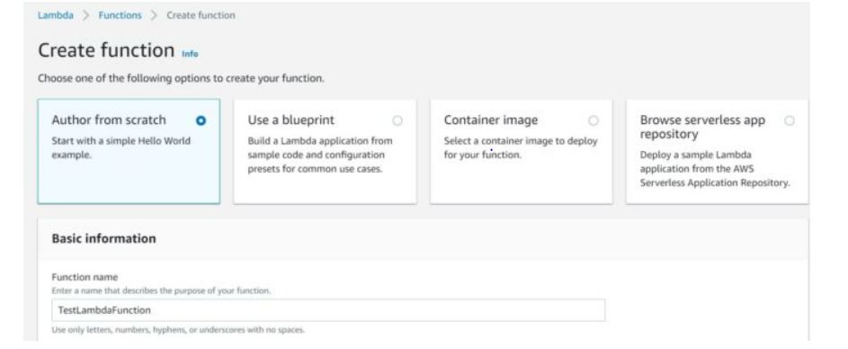

Then provide a valid fucntion name, Runtime info and select the appropriate architecture.

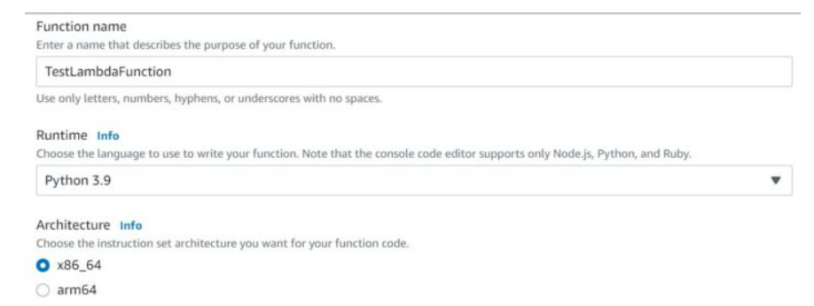

Chose the language to use to write your function, Select the runtime function as python 3.9.

Select Create a new role with basic lambda permissions. Click on Create function.

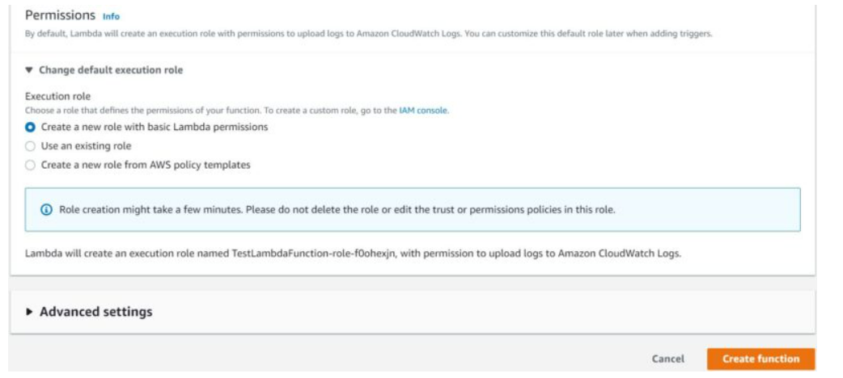

You will see your Lambda function created like as shown below. In our case, we have created a lambda function named Testlambdafunction.

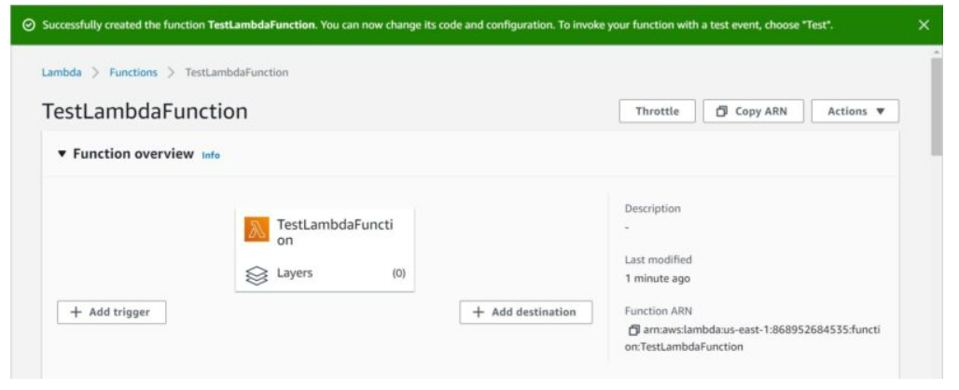

After creating lambda function , you can now change its code and configuration. You can remove default code created under lambdafunction.py.

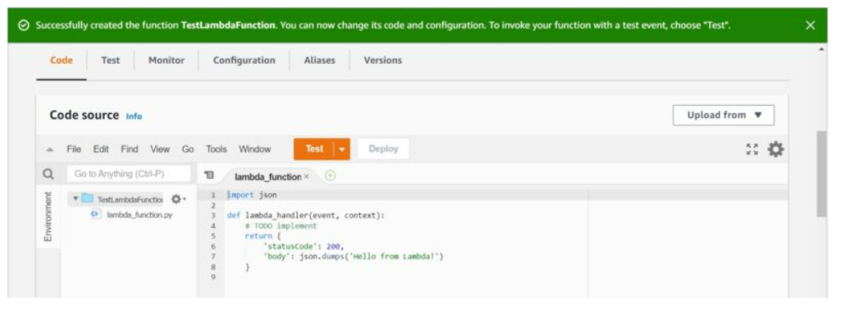

You can then put the below code in lambdafunction.py python file.

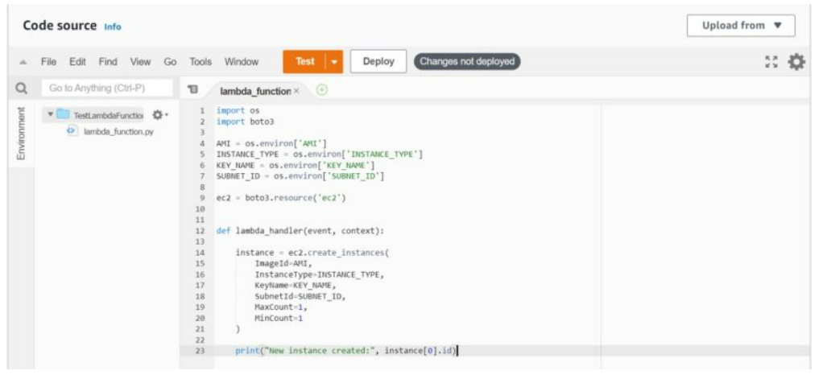

To set the value of AMI in environment varible, you need to select your machine image from AMIs list and copy the image name. Since here we going to use Amazon ubuntu AMI 64-bit so we will copy the id

**Test Your Function**

Now that function is created, it is time to test your function. For that you need to go to Test tab as shown below and then click on test.

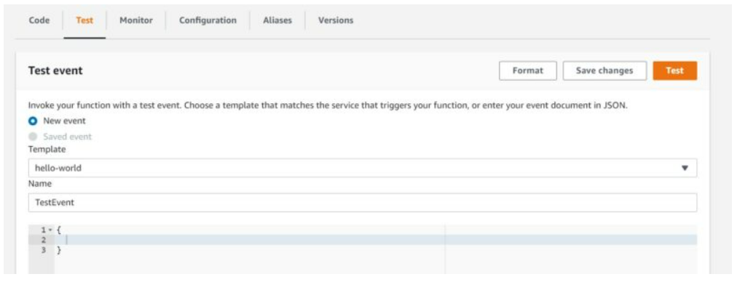

If everything goes well then you should see below succeeded message in the Execution result. This also means that your EC2 instance is created successfully.

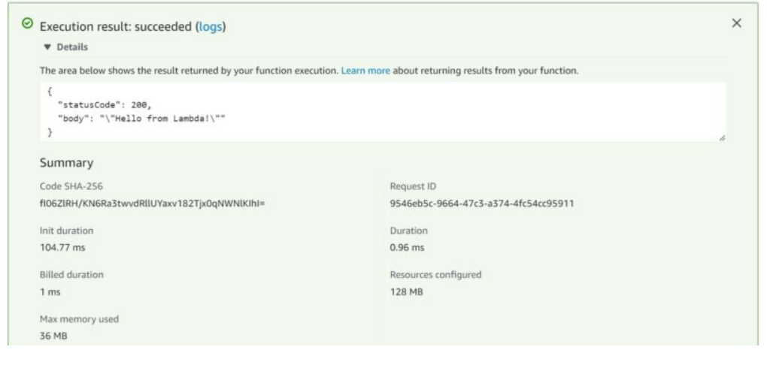

**Verify EC2 Instance**

To verify the successful creation of EC2 instance, go to services EC2 and check for running Instances. You will see an Ec2 instanc created by lambda function.